Practical - 1
Practical Title: Project Initiation, Requirement Analysis, Sitemap, Wireframe, and GitHub Setup

Problem Definition: Initiate the semester-long StudentHub portal by identifying the problem scope, user roles, key modules, navigation flow, and minimum 10 pages. Create a sitemap, low-fidelity wireframe, project folder structure, README file, and GitHub repository.

Theory

What is URL and parts of URL?
Answer :
A URL (Uniform Resource Locator) is the address of a webpage or resource on the internet. It tells the browser where the webpage is located and how to access it.
Example:
https://www.example.com/about.html
Parts of a URL:
- Protocol: https:// – Defines how data is transferred.
- Domain Name: www.example.com – The website's address.
- Path: /about.html – The specific page or file on the website.

How does HTML file process in web browser?
Answer:
When a user enters a website address or opens an HTML file, the browser loads the HTML document. It reads the HTML code from top to bottom and creates the page structure. Then it loads the CSS for styling and JavaScript for interactivity. Finally, the browser displays the fully rendered webpage on the screen.

3. How will page navigation flow managed among all HTML pages?
Answer:
Page navigation is managed using HTML links (<a> tags). Each page contains links to other pages such as Home, About, Contact, Profile, and Dashboard. When a user clicks a link, the browser opens the corresponding HTML page. This creates a smooth and organized navigation flow throughout the website.

4. How will GitHub commits be maintained after each practical?
Answer:
After completing each practical, the updated files are saved and uploaded to the GitHub repository using a new commit. Every commit includes a clear message describing the changes, such as "Added Login Page" or "Updated Contact Form". This helps keep track of progress, maintain version history, and makes it easy to review or restore previous work if needed.

Implementation/ Output/Result

Required Analysis:

create new account page
login page
dashboard
profile
course
assignment detail
attendance
result detail page
contact

Sitemap:
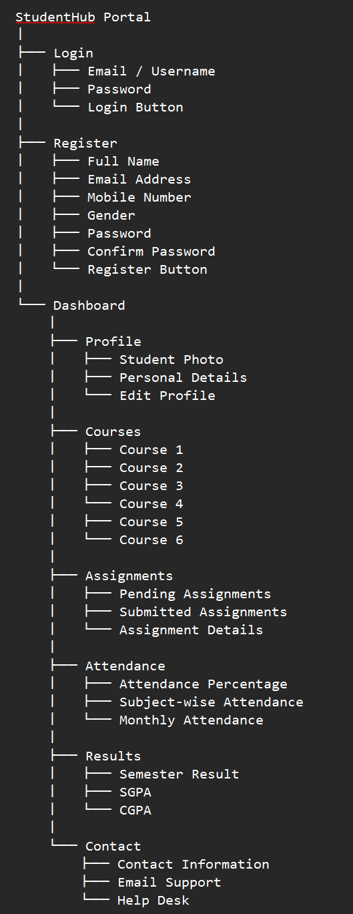

Evidence of Work (Screenshots)
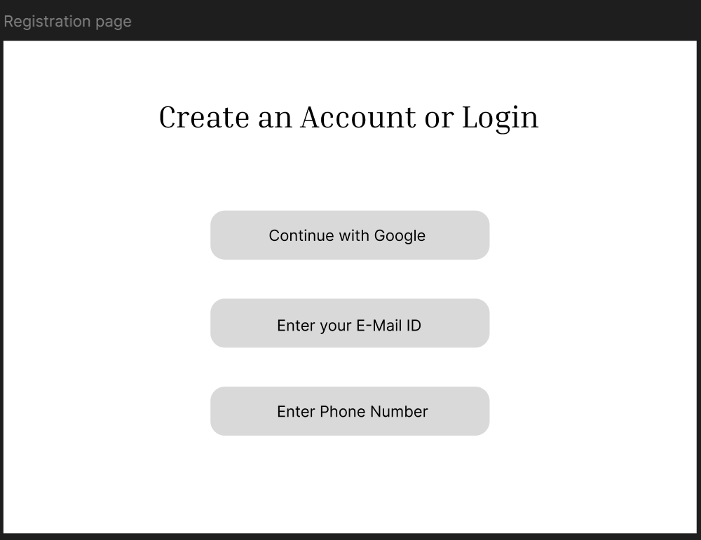
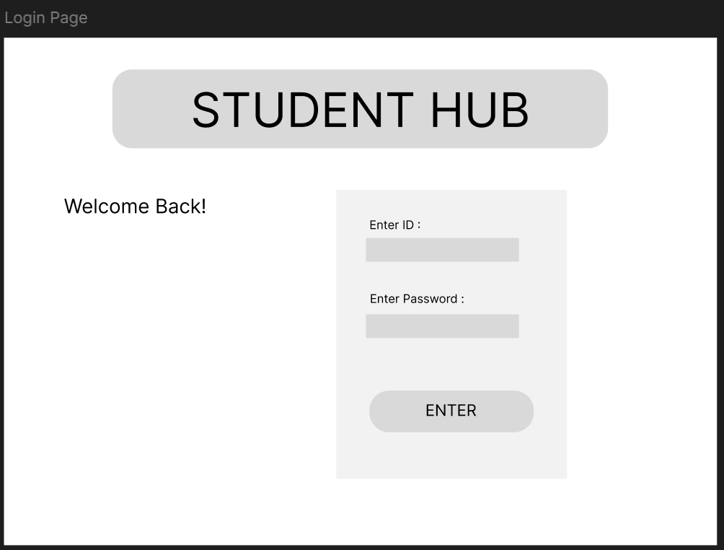
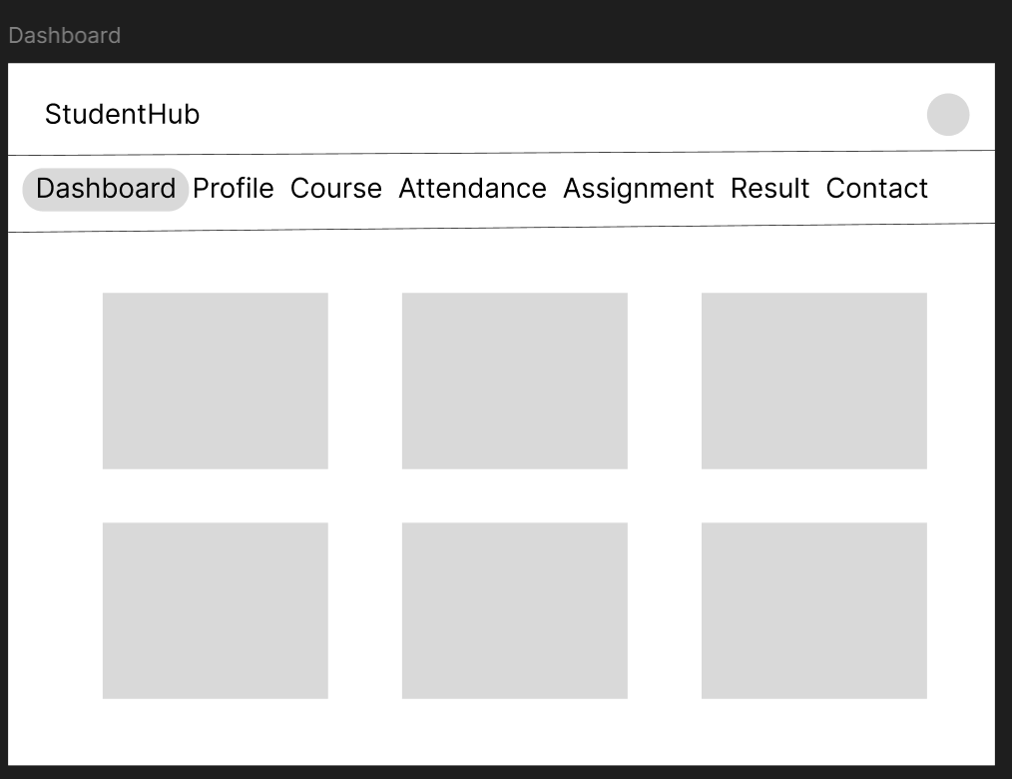
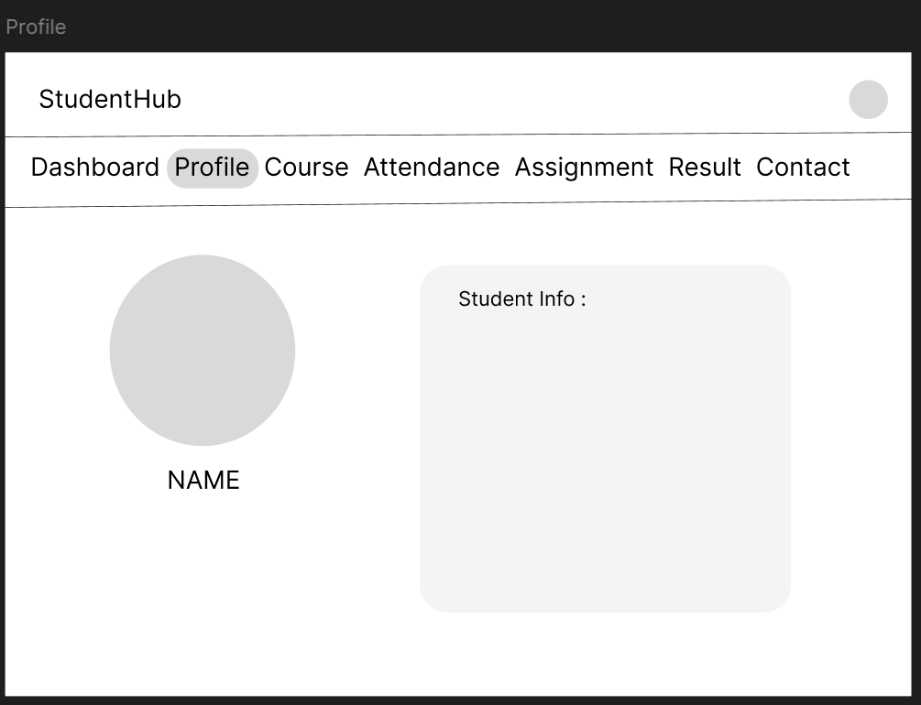
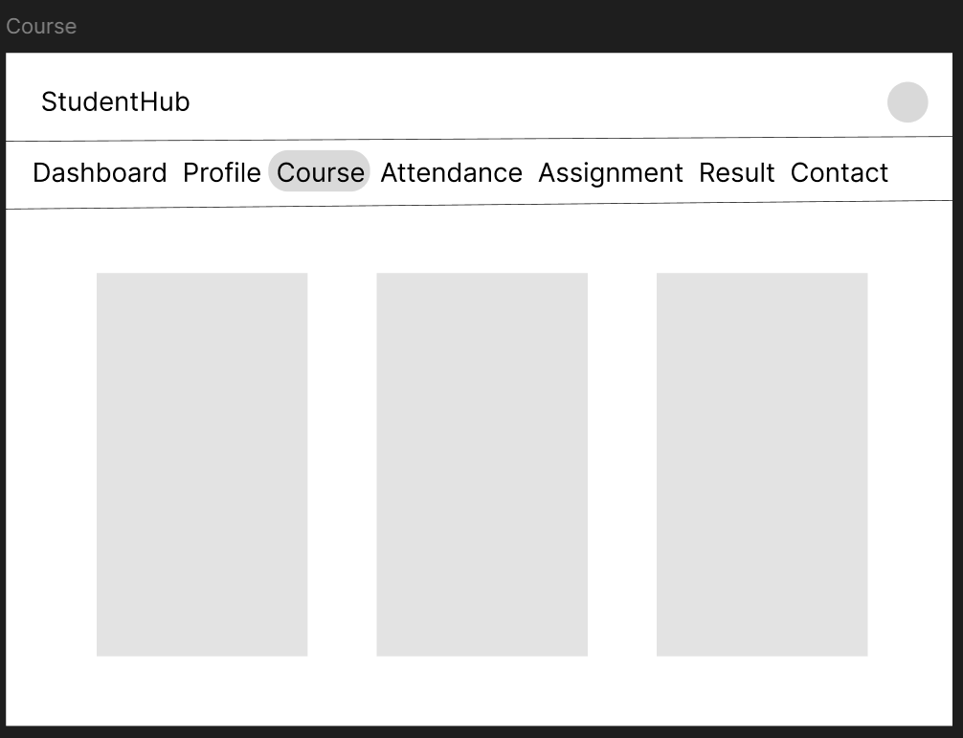
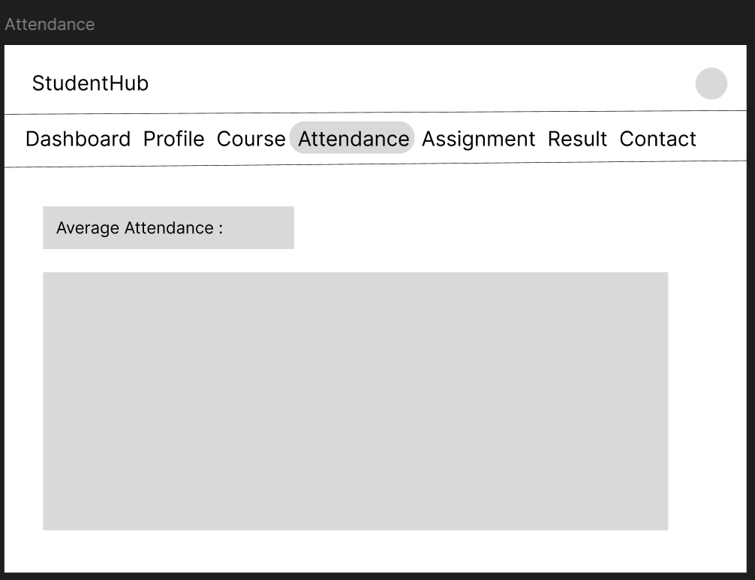
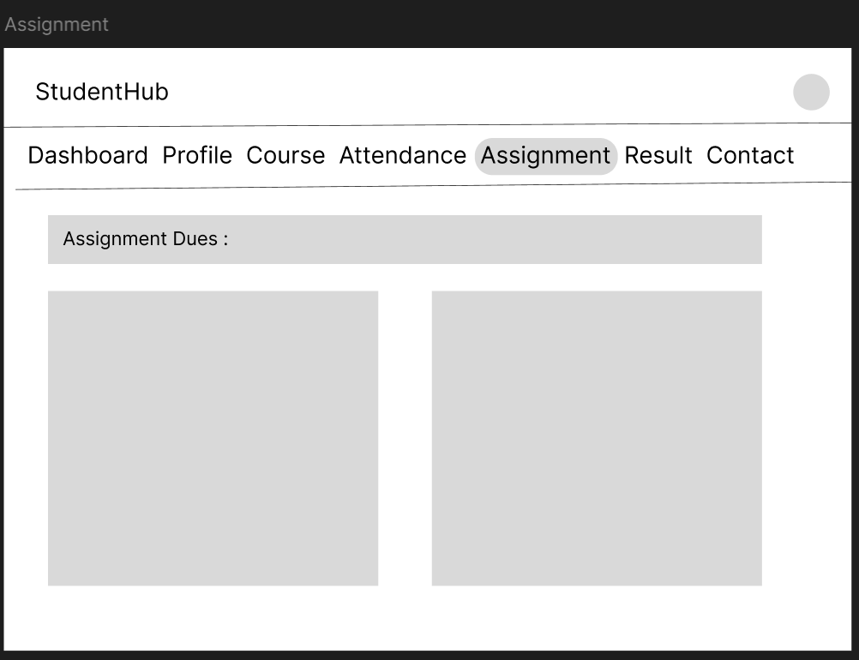
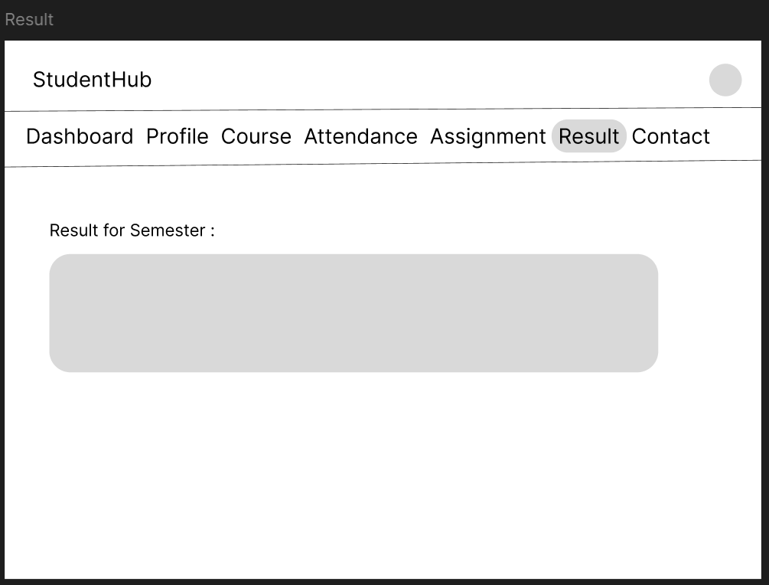
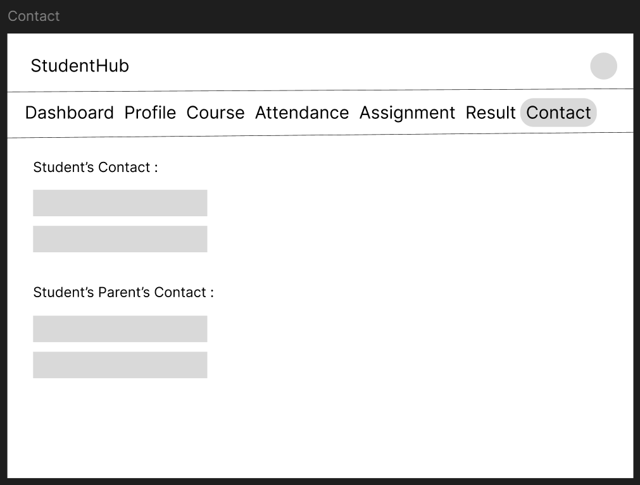

GitHub Repository Link:
https://github.com/kansagarahasti24/WDF/tree/main/Practical%201

Challenges Faced:
- Understanding the requirements of the Student Hub Portal.
- Organizing all pages correctly in the sitemap.
- Designing a simple and user-friendly wireframe.
- Deciding the proper navigation between pages.
- Creating the report in Microsoft Word because I was not familiar with formatting.
- Managing time while completing all the tasks.

Learning Outcomes:

- Learned how to analyze project requirements.
- Understood how to create a sitemap for website navigation.
- Gained experience in designing wireframes.
- Improved planning and website design skills.
- Learned basic Microsoft Word formatting for documentation.

Faculty Remarks: (Keep this blank for faculty)

